Horticulture Science
Agriculture, Food, and Natural Resources
__________

Level Four
Level One
Level Two
Level Three

¹ Satisfies one lab science credit required for graduation. ²Statewide dual credit available.

ABOUT THE PROGRAM OF STUDY
Tennessee Specific Industry Certification (TSIC) for Horticulture Science Pilot 2018-19
Dual credit/dual enrollment options include:
- Course A
- Course B
Horticulture Science is a broad and diverse program of study ranging from improving human environment to producing fruits and vegetables to managing of recreational and sports turf. Upon completion of this program of study, proficient students will be prepared for careers in the management of greenhouse operations, horticulture production, landscape design and maintenance, and turf management industries or further study in the horticultural, or plant sciences. This course is available as a statewide dual credit course which can count as the introduction to plant science course at the post secondary level.
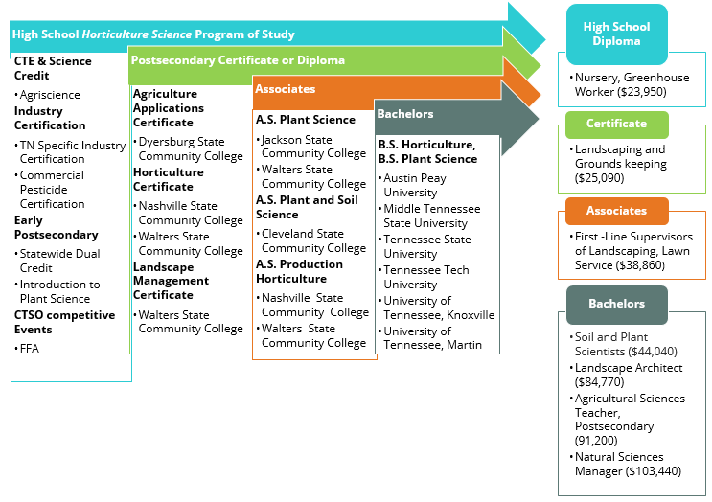
Tennessee Specific Industry Certification for Horticulture Science aligned with postsecondary credit and other stackable credentials is being piloted for this program of study in 2017-18.

This is not an exhaustive list of all of the opportunities available in Tennessee.

Horticulture Science Related Occupations with the Largest Annual Percentage of Openings in Tennessee (2014-2024)
Occupation | 2014 Estimated Employment | 2024 Projected Employment | Employment Change | Annual Avg. Percent Change
11-9121 Natural Sciences Managers | 510 | 530 | 10 | 5%
25-1041 Agricultural Sciences Teachers, Postsecondary – Plant & Soil Science, Horticulture | 260 | 290 | 10 | 14%
25-1042 Biological Science Teachers, Postsecondary | 1,420 | 1,770 | 60 | 24%
25-9021 Farm and Home Management Advisors, Crop | 150 | 170 | 0 | 15%
37-1012 First-Line supervisors of landscaping, lawn service, and groundskeeping workers | 4,400 | 4,670 | 280 | 6%
Source: TN Dept of Labor & Workforce Dev, Div Emp Sec, R&S
Downloaded: May 17, 2017
2024 Job projections for first-line supervisors of landscaping, lawn service, and groundskeeping workers.

Source: Tennessee Department of Labor & Workforce Development. Accessed Aug. 2017
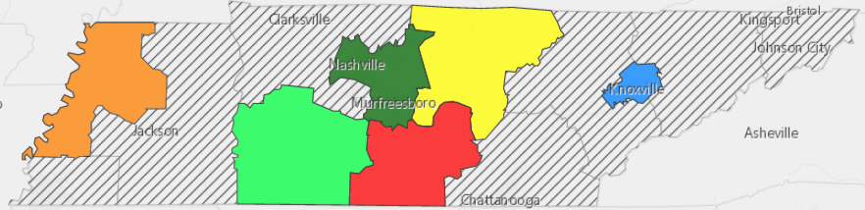

POSTSECONDARY OPTIONS
Have you registered for the Tennessee Promise? Seniors enrolled in this program have the chance to attend a two-year program at a Tennessee College of Applied Technology (TCAT), community college, or some two-year university programs for free! To learn more, please see your school counselor or visit http://www.tennesseepromise.gov.
Postsecondary Offerings
Program of Study | School | Degree Program
Plant Science | University of Tennessee, Knoxville | Bachelor’s, Master’s , and/or Doctoral
Plant & Soil Science – Golf Course & Landscape Management | University of Tennessee, Martin | Bachelor’s
Agriculture, Greenhouse Management | Waters State Community College | Applied Associate’s, Associate’s
Landscaping and Turf Management | Chattanooga State Community College | Technical Diploma

For more college and career planning resources, visit http://collegefortn.gov.
For more information, contact:
Name of High School
Name of School System
CTE Director: [enter name]
Email
Teacher: [enter name]
Email
Students in this program of study will be eligible to join FFA. In addition to school events, students will be able to compete at the district, regional, state, and national levels. Through FFA, students not only learn about agriculture, but also professionalism, leadership, and soft skills. Walk away from your high school career with experience in competing, networking, applying course content, and more! See your agriculture teacher to learn more about FFA or visit http://www.tnffa.org.

