Veterinary and animal science
Agriculture, Food, and Natural Resources
__________

Level Four
Level One
Level Two
Level Three

¹ Satisfies one lab science credit required for graduation.
Tennessee Specific Industry Certification (TSIC) for Animal Science
Pilot 2018-19
Dual credit/dual enrollment options include:
- Course A
- Course B
ABOUT THE PROGRAM OF STUDY
Veterinary and Animal Science is designed to prepare students to further their education for rewarding careers related to both companion and farm animals. This program of study provides rigorous technical skills, academic knowledge, higher-order reasoning, problem-solving skills, work attitudes, and employment skills. Course content covers such topics as principles of health and disease, basic animal care and nursing, clinical and laboratory procedures, and the anatomical/physiological systems of a range of small and large animals. Upon completion of this program of study, students will be prepared to pursue further study in the veterinary and animal sciences at the postsecondary level or to seek gainful employment.

This is not an exhaustive list of all of the opportunities available in Tennessee
Veterinary and Animal Science related Occupations with the Largest Annual Percentage of Openings in Tennessee (2014-2024)
Occupation | 2014 Estimated Employment | 2024 Projected Employment | Employment Change | Annual Avg. Percent Change
11-9121 Natural Sciences Managers, Animal Biology/Zoology/Genetics | 510 | 530 | 10 | 5%
25-1041 Agricultural Science Teacher, Postsecondary, Animal/Livestock husbandry/Production/Training | 260 | 290 | 10 | 14%
25-1042 Biological Science Teachers, Postsecondary, Zoology/Animal Biology | 1,420 | 1,770 | 60 | 24%
25-1071Health Specialties Teachers, Postsecondary, Veterinary Health | 5,100 | 7,010 | 2770 | 38%
29-1131 Veterinarians | 1,210 | 1,440 | 230 | 19%
29-2056 Veterinary technologists and technicians | 1,620 | 2,240 | 620 | 38%
Source: TN Dept of Labor & Workforce Dev, Div Emp Sec, R&S
Downloaded: May 17, 2017
The job outlook for this program of study projects continued growth in veterinarians.

Source: Tennessee Department of Labor and Workforce Development. Accessed Aug. 15, 2017

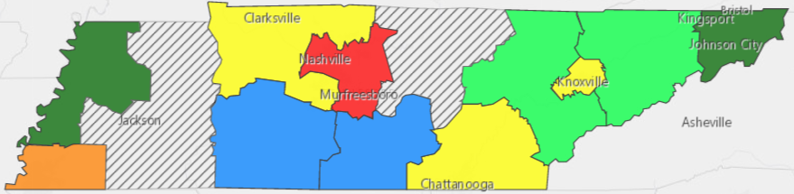

POSTSECONDARY OPTIONS
Have you registered for the Tennessee Promise? Seniors enrolled in this program have the chance to attend a two-year program at a Tennessee College of Applied Technology (TCAT), community college, or some two-year university programs for free! To learn more, please see your school counselor or visit http://www.tennesseepromise.gov .
Postsecondary Offerings Aligned to this Program of Study
Program of Study | School | Degree Program
Animal Science | University of Tennessee, Knoxville | Bachelor’s, Master’s , and/or Doctoral
Animal Science / Horse Science | Middle Tennessee State University | Bachelor’s, Master’s
Animal Science – Pre Veterinary Medicine / Agriculture – Animal Science Pathway | Walters State Community College  Jackson State Community College | Associate’s (TTP)
For more college and career planning resources, visit http://collegefortn.org.

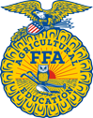
Students in this program of study will be eligible to join FFA. In addition to school events, students will be able to compete at the district, regional, state, and national levels. Through FFA, students not only learn about agriculture, but also professionalism, leadership, and soft skills. Walk away from your high school career with experience in competing, networking, applying course content, and more! See your agriculture teacher to learn more about FFA or visit http://www.tnffa.org.

Name of High School
Teacher: [enter name]
Email
Name of School System
CTE Director: [enter name]
Email
For more information, contact:
Email

