RESIDENTIAL & COMMERCIAL CONSTRUCTION
__________

Level One
Level Two
Level Three
Architecture & Construction
__________

Level Four

ABOUT THE PROGRAM OF STUDY
Industry certification options include:
- NCCER Core Curriculum
- NCCER Construction Technology

The Residential & Commercial Construction program of study prepares students for the various disciplines of construction, providing students with the opportunity to develop a holistic understanding of the building systems and components required for a construction project. Students will be able to interpret construction drawings, perform basic math skills, demonstrate the construction crafts required for each phase of a construction project and safely use and maintain appropriate tools, equipment, and resources to accomplish construction project goals. Course content covers industry specific business concepts, project management, and career opportunities. In the third level course, programs have the option to select a focus area. The fourth level course, Construction Practicum, places students with industry partners to complete a capstone construction project.
Career Opportunities

CAREER OPPORTUNITIES
The construction and extraction occupation group is projected to grow by 10.8 percent in Tennessee between 2014 and 2022 with a total annual average of 3,205 openings. Within the installation, maintenance, and repair occupation group, an additional 3,120 total annual average openings are projected (not including vehicle installers and repairers). Opportunities are available in a broad range of occupations. Job outlook is positive in all regions of the state; however, more opportunities are available in urban and surrounding areas.
Occupation | Total Percent Change | Annual Avg. Openings
Maintenance & Repair Workers, General | 7.7% | 880
Construction Laborers | 12.9% | 840
Electricians | 9.0% | 340
First-Line Supervisors of Mechanics, Installers, & Repairers | 6.3% | 335
HVAC/R Mechanics & Installers | 10.9% | 275
Construction Managers | 4.6% | 235
Civil Engineers | 17.6% | 215
Supervisors of Construction & Extraction Workers | 9.2% | 210
Carpenters | 5.0% | 200
Operating Engineers & Other Construction Equipment Operators | 14.3% | 185
Cost Estimators | 11.9% | 170
Sheet Metal Workers | 14.4% | 160
Electrical Power-Line Installers & Repairers | 10.0% | 155
Plumbers, Pipefitters, & Steamfitters | 6.6% | 140

Construction Occupations with the Most Annual Average Openings in Tennessee (2014-2022)

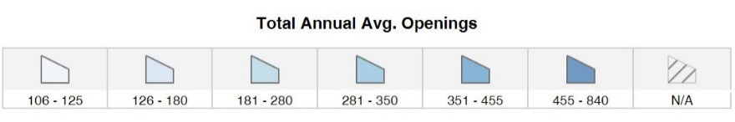
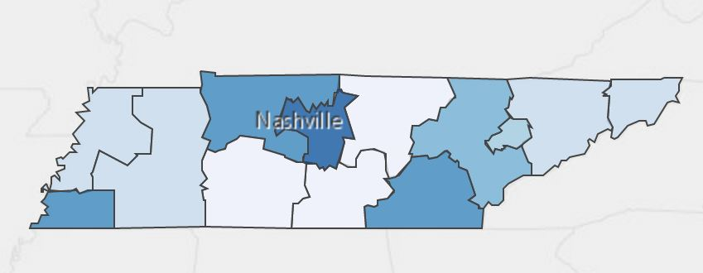
Annual Average Openings for Construction & Extraction Occupations in Tennessee (2014-2022)
Source: TN Department of Labor and Workforce Development. (2015). Employment Security Division, Labor Market Information Section, on the internet at https://www.jobs4tn.gov/ (visited Feb. 10, 2016)

Students in this program of study will be eligible to join SkillsUSA. In addition to school events, students will be able to compete at the regional, state, and national level. Through SkillsUSA, students not only learn about construction, but also professionalism, leadership, and workplace skills. Walk away from your high school career with experience in competing, networking, applying course content, and more!
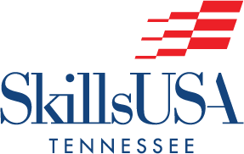
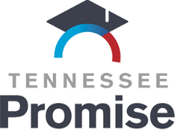
See your teacher to learn more about SkillsUSA or visit http://tnskillsusa.com/.
For more information, contact:
Central High School
County Name Schools
CTE Director: Susan Smith Susan.Smith@school.edu
Instructor: Bob Johnson Bob.Johnson@school.edu

School | Degree Program
TCAT Nashville | Building Construction Technology
TCAT Murfreesboro | HVAC/R
Cleveland State | Surveying
TCAT Paris | Residential Building Maintenance
Chattanooga State | Construction Management (concentration)
Chattanooga State | Construction Engineering Technology
For more college and career planning resources, visit http://collegefortn.org.

POSTSECONDARY OPTIONS

community college, or some 2-year university programs for free! To learn more, please see your school counselor or visit http://www.tennesseepromise.gov.

Have you registered for the Tennessee Promise? Seniors enrolled in this program have the chance to attend a two-year program at a Tennessee College of Applied Technology (TCAT), community college, or some 2-year university programs for free! To learn more, please see your school counselor or visit http://www.tennesseepromise.gov.

