Level One
Level Two
Level Three
AUDIO/ VISUAL PRODUCTION
__________

Arts, A/V Technology, & Communications
__________

Level Four

ABOUT THE PROGRAM OF STUDY
Dual credit/ dual enrollment options include:
Audio Visual Production

The A/V Production program of study is designed for students interested in a range of entertainment and news media fields. Course content centers on production of various television, cinema, radio, and other audio and video products, including commercials, music, news, interactive programming, and film. Students complete all phases of the production process including planning, coordinating, capturing, editing, and distributing productions. Topics include but are not limited to concept creation, scripting, interviewing, budgeting, scheduling, set design, engineering, field and studio production, and editing, as well as operating production equipment such as cameras, lights, and audio equipment.

This is not an exhaustive list of all of the opportunities available in Tennessee.
Occupation | Total Percent Change | Annual Avg. Openings
Writers and Authors | 12.20% | 65
Audio and Video Equipment Technicians | 13.80% | 60
Radio and Television Announcers | 19.80% | 60
Editors | 8.60% | 50
Reporters and Correspondents | -4.60% | 30
Technical Writers | 10.20% | 25
Broadcast Technicians | 16.50% | 20
Media and Communication Workers, All Other | 10.70% | 15
Sound Engineering Technicians | 9.80% | 15
Camera Operators, Television, Video, and Motion Picture | 12.80% | 10
Film and Video Editors | 9.90% | 10
Broadcast News Analysts | 18.20% | 5

Media and Communications Occupations with the Most Annual Average Openings in Tennessee (2014-2022)
CAREER OPPORTUNITIES
The Media and Communications Workers occupation group is projected to grow by 12.7 percent in Tennessee between 2014 and 2022. Job opportunities are strongest in urban and surrounding areas in Tennessee. Job outlook for this pathway statewide is very competitive due to the large number of training completers in relation to job openings expected annually. Occupations with the greatest number of annual average openings include writers and authors and audio and video equipment technicians.

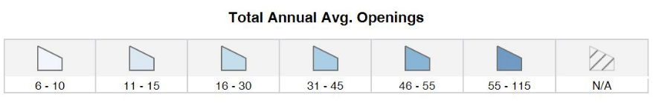
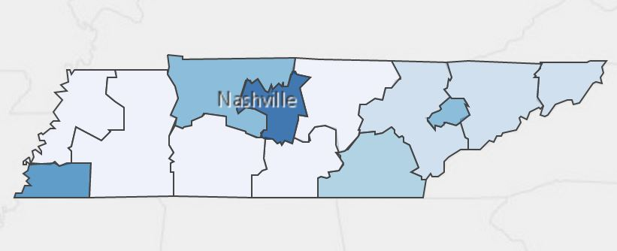
Annual Average Openings for Media and Communications Workers in Tennessee (2014-2022)

Source: TN Department of Labor and Workforce Development. (2015). Employment Security Division, Labor Market Information Section, on the internet at https://www.jobs4tn.gov/
See your teacher to learn more about SkillsUSA or visit http://tnskillsusa.com/.
To learn more, please see your school counselor or visit http://www.tennesseepromise.gov.

Students in this program of study will be eligible to join SkillsUSA. In addition to school events, students will be able to compete at the regional, state, and national level. Through SkillsUSA, students not only learn about A/V production, but also professionalism, leadership, and workplace skills. Walk away from your high school career with experience in competing, networking, applying course content, and more!
For more information, contact:
School High School
County Name Schools
CTE Director: Name
Email
Instructor: Name
Email

School | Degree Program
Pellissippi State | Videography
Pellissippi State | Media Technologies
Middle Tennessee State University | Video and Film Production
University of Tennessee Knoxville | Communications
University of Tennessee Knoxville | Journalism
For more college and career planning resources, visit http://collegefortn.org.

POSTSECONDARY OPTIONS

Have you registered for the Tennessee Promise? Seniors enrolled in this program have the chance to attend a two-year program at a Tennessee College of Applied Technology (TCAT), community college, or some 2-year university programs for free! To learn more, please see your school counselor or visit http://www.tennesseepromise.gov.

