ADVANCED STEM APPLICATIONS

STEM
Level Four
Level One
Level Two
Level Three

Industry Certifications options include:
Certified Solidworks Associate (CWSA) Academic
Autodesk inventor Certified User

ABOUT THE PROGRAM OF STUDY
The Advanced STEM Applications program of study designed for students interested in the exciting careers available in the high-demand fields of science, technology, engineering, and mathematics. This program of study is uniquely structured to offer students an overview of STEM fields, occupations, and applications in the first year, followed by more specialized study of the scientific inquiry or engineering design process in subsequent years, culminating in a portfolio and internship experience. Upon completion of these POS, students will be prepared to pursue engineering studies or an advanced study in the STEM field of their choice at a variety of postsecondary institutions.

This is not an exhaustive list of all of the opportunities available in Tennessee.

CAREER OPPORTUNITIES
As Tennessee strives to maintain and advance its economic stability and workforce, we must make it our goal to increase the number of students who come through and out of K–16 education prepared for these high-demand STEM-related careers. Unfortunately, students who choose to pursue these careers are often inadequately prepared to take on the challenges these positions demand. Secondary and postsecondary students are often lacking critical thinking, problem solving, and collaborative skills that are imperative for success. This too often affects their on the job performance. Students often struggle not only with academic knowledge when applying for a job, but they also face challenges involving real world applications like problem solving, conducting independent research, and proactively seeking solutions.
Employment Projections for STEM careers in Tennessee
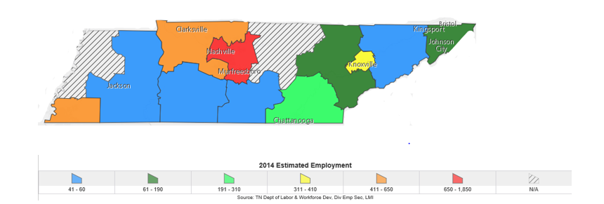
POSTSECONDARY OPTIONS
School | Degree Program
Roane State Community College | Geographic Information Systems Technologist
Nashville State Community College | Electrical Engineering Technician
Tennessee Tech University | Civil Engineer
For more college and career planning resources, visit http://collegefortn.org.

Have you registered for the Tennessee Promise? Seniors enrolled in this program have the chance to attend a two-year program at a Tennessee College of Applied Technology (TCAT), community college, or some two-year university programs for free! To learn more, please see your school counselor or visit http://www.tennesseepromise.gov .

STEM Related Occupations with the most Annual Average Openings in Tennessee (2014-2024)
Occupation | 2014 Estimated Employment | 2024 Projected Employment | Total Percent Change
Software Developer Applications | 4,840 | 6,160 | 27.00%
Mechanical Engineer | 4,660 | 5,030 | 8.00%
Geospatial Information Scientists and Technologists | 2,130 | 2,160 | 2.00%
Tennessee Department of Labor and Workforce Development, Job4TN Online. (2017). Occupational Projections (Long-term). Retrieved from https://www.jobs4tn.gov/vosnet/analyzer/results.aspx?session=occproj
Students in this program of study will be eligible to join SkillsUSA and TSA. SkillsUSA improves the quality of America’s skilled workforce through a structured program of citizenship, leadership, employability, technical and professional skills training. Visit http://www.skillsusa.org. The Technology Student Association fosters personal growth, leadership, and opportunities in Science, Technology, Engineering, and Mathematics (STEM); members apply and integrate these concepts through co-curricular activities, competitions, and related programs.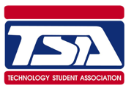

For more information, contact:
High School Name
County Name
CTE Director: Name
Email
Instructor: Name
Email

