DISTRIBUTION & LOGISTICS
__________

Level One
Level Two
Level Three
Transportation, Distribution, & Logistics
__________

ABOUT THE PROGRAM OF STUDY
Dual credit/ dual enrollment options:
- Course A
- Course B

The Distribution & Logistics program of study prepares students for many management and operations careers in the transportation industry. In this program of study, students learn about the dynamics of distribution networks, the managing and tracking of inventory, how distribution and logistics operations fit within the supply chain of a product or a business, and the problem solving skills to design logistics solutions for businesses. Students will have had the opportunity to participate in a Work-based Learning: Career Practicum in a classroom setting or in a transportation, distribution, and logistics-related business, and be prepared for advanced postsecondary study in transportation, distribution, and logistics related fields.
Career Opportunities

Occupation | Total Percent Change | Annual Avg. Openings
Laborers and Freight, Stock, and Material Movers, Hand | 7.6% | 3,460
Heavy and Tractor-Trailer Truck Drivers | 11.0% | 1,610
Packers and Packagers, Hand | 6.4% | 655
Light Truck or Delivery Services Drivers | 3.9% | 585
Supervisors, Transportation and Material Moving Workers | 7.9% | 425
Industrial Truck and Tractor Operators | 0.6% | 410
Bus Drivers, School or Special Client | 8.8% | 275
Driver/Sales Workers | 8.4% | 215
Water Transportation Workers | 10.0% | 145
Bus Drivers, Transit and Intercity | 21.7% | 130
Transportation, Storage, and Distribution Managers | 8.0% | 130

Annual Average Openings for Transportation and Material Moving Occupations in Tennessee (2014-2022)
CAREER OPPORTUNITIES
The transportation and material moving occupations group is projected to grow 7.8 percent in Tennessee between 2014 and 2022 with a total annual average of 9,230 openings. Additionally, 130 annual average openings are projected for transportation, storage, and distribution managers and 70 annual average openings are projected for logisticians. Job outlook is anticipated to be positive statewide. The most annual average opening are projected for the Memphis area; however, at least 150 annual average openings are projected for each region of the state.

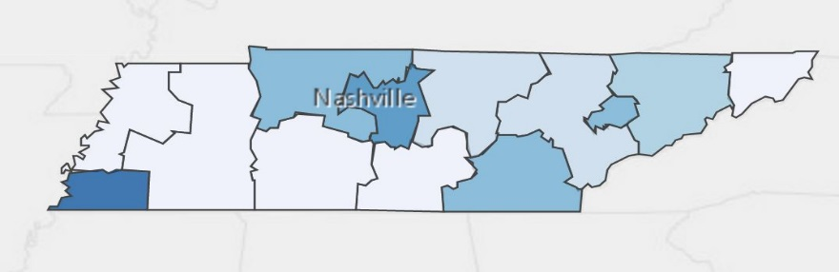
POSTSECONDARY OPTIONS

Annual Average Openings for Transportation and Material Moving Occupations in Tennessee (2014-2022)
Source: TN Department of Labor and Workforce Development. (2015). Employment Security Division, Labor Market Information Section, on the internet at https://www.jobs4tn.gov/ (visited Feb. 25, 2016)
Have you registered for the Tennessee Promise? Seniors enrolled in this program have the chance to attend a two-year program at a Tennessee College of Applied Technology (TCAT), community college, or some 2-year university programs for free! To learn more, please see your school counselor or visit http://www.tennesseepromise.gov.

community college, or some 2-year university programs for free! To learn more, please see your school counselor or visit http://www.tennesseepromise.gov.

School | Degree Program
Southwest TN | Logistics/ Transportation Management
Nashville State | Logistics/ Transportation Management
Volunteer State | Logistics/ Transportation Management
Walters State | Operations Management
For more college and career planning resources, visit http://collegefortn.org.

Students in this program of study will be eligible to join SkillsUSA. In addition to school events, students will be able to compete at the regional, state, and national level. Through SkillsUSA, students not only learn about transportation, but also professionalism, leadership, and workplace skills. Walk away from your high school career with experience in competing, networking, applying course content, and more!
For more information, contact:
Central High School
County Name Schools
CTE Director: Susan Smith Susan.Smith@school.edu
Instructor: Bob Johnson Bob.Johnson@school.edu

See your teacher to learn more about SkillsUSA or visit http://tnskillsusa.com/.

