AUTOMOTIVE MAINTENANCE & LIGHT REPAIR
__________

Level One
Level Two
Level Three
Transportation
__________

Level Four

ABOUT THE PROGRAM OF STUDY
Available industry certification:
- ASE Student Certification- Maintenance & Light Repair
Dual credit/ dual enrollment options:
- Course A
- Course B

The Automotive Maintenance and Light Repair program of study prepares students for entry into the automotive service industry with an ASE Student Certification. Students study and service automotive HVAC systems, engine performance systems, automatic and manual transmission/transaxle systems, and practice workplace soft skills. Upon completion of this program of study, students will be equipped with the knowledge and skills to be a successful automotive service technician, have satisfied course requirements to meet the National Automotive Technicians Education Foundation (NATEF) standards, and be prepared to pursue further study at a Tennessee College of Applied Technology or other postsecondary institution.
Career Opportunities

Occupation | Total Percent Change | Annual Avg. Openings
Automotive Service Technicians and Mechanics | 3.0% | 420
First-Line Supervisors of Mechanics, Installers, and Repairers | 6.3% | 335
Bus and Truck Mechanics and Diesel Engine Specialists | 5.4% | 170
Mechanical Engineers | 5.3% | 170
Tire Repairers and Changers | 10.5% | 125
Mobile Heavy Equipment Mechanics, Except Engines | 7.6% | 100
Electrical Engineers | 7.5% | 80
Automotive Body and Related Repairers | 3.8% | 75
Electrical and Electronic Engineering Technicians | 0.1% | 55
Electronics Engineers, Except Computer | 17.3% | 50

Automotive Maintenance & Light Repair Related Occupations with the Most Annual Average Openings in Tennessee (2014-2022)
CAREER OPPORTUNITIES
The vehicle and mobile equipment mechanics, installers, and repairers occupation group is projected to grow by 4.7 percent in Tennessee between 2014 and 2022 with a total annual average of 1,080 openings. Automotive service technicians and mechanics are projected to have the most annual average openings with 420. Related occupations requiring a bachelor’s degree include mechanical engineers and electrical engineers.

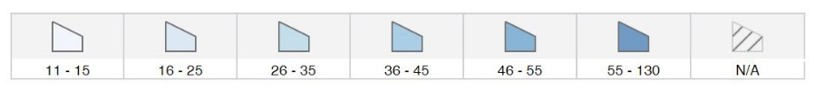
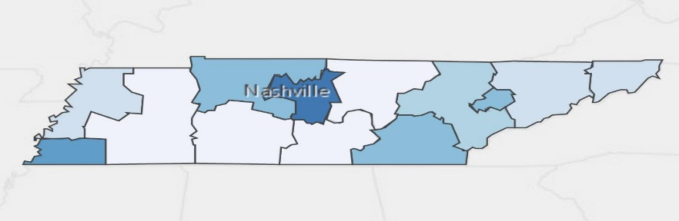
Annual Average Openings for Automotive Service Technicians and Mechanics in Tennessee (2014-2022)

Source: TN Department of Labor and Workforce Development. (2015). Employment Security Division, Labor Market Information Section, on the internet at https://www.jobs4tn.gov/ (visited Feb. 25, 2016)
Students in this program of study will be eligible to join SkillsUSA. In addition to school events, students will be able to compete at the regional, state, and national level. Through SkillsUSA, students not only learn about automotive repair, but also professionalism, leadership, and workplace skills. Walk away from your high school career with experience in competing, networking, applying course content, and more!

POSTSECONDARY OPTIONS

School | Degree Program
TCAT Jackson | Automotive Technology
TCAT Memphis | Automotive Technology
TCAT Newbern | Automotive Technology
TCAT Memphis | Diesel Technology
Southwest TN Community College | Automotive Service Technology
University of Memphis | Mechanical Engineering
For more college and career planning resources, visit http://collegefortn.org.

community college, or some 2-year university programs for free! To learn more, please see your school counselor or visit http://www.tennesseepromise.gov.

Have you registered for the Tennessee Promise? Seniors enrolled in this program have the chance to attend a two-year program at a Tennessee College of Applied Technology (TCAT), community college, or some 2-year university programs for free! To learn more, please see your school counselor or visit http://www.tennesseepromise.gov.

For more information, contact:
Central High School
County Name Schools
CTE Director: Susan Smith Susan.Smith@school.edu
Instructor: Bob Johnson Bob.Johnson@school.edu

See your teacher to learn more about SkillsUSA or visit http://tnskillsusa.com/.

