Tennessee
Department of Health

Healthcare Associated Infections &

Antimicrobial Resistance Program
Containment of Multidrug-Resistant Organism Tabletop Exercise
Situation Manual

This Situation Manual (SITMAN) provides exercise participants with all the necessary tools for their roles in the exercise. Some exercise material is intended for the exclusive use of exercise planners, facilitators, and evaluators, but players may view other materials that are necessary to their performance. All exercise participants may view the SITMAN.

Exercise Overview
Exercise Name | Tennessee Department of Health Healthcare Associated Infection and Antimicrobial Resistance Program Containment of Multidrug-Resistant Organism Containment Tabletop Exercise
Exercise Dates | February 7, 2018 – March 8, 2018 Exercise will be held at varying locations throughout the state.
Scope | This exercise is a scheduled 6-hour Tabletop Exercise (TTX) for Tennessee Department of Health Healthcare Associated Infection and Antimicrobial Resistance Program.  This Tabletop will test the plan for multi-drug resistant organism (MDRO) containment across the continuum of care and increase awareness of new Antimicrobial Resistance Laboratory Network (ARLN) resources for containment and response.
Mission Area(s) | Response
Core Capabilities | HPP:  Capability 1- Foundation for Health Care & Medical Readiness  Capability 2 -Health Care & Medical Response Coordination  Capability 3- Continuity of Health Care Service Delivery  Capability 4- Medical Surge
Objectives | - Define plans for multi-drug resistant organism (MDRO) containment across the continuum of care.  - Increase awareness of new Antimicrobial Resistance Laboratory Network (ARLN) resources for containment and response.  - Collaborate between laboratory, epidemiologists, healthcare facility staff, and other key players to apply containment principles.
Threat or Hazard | Infectious Disease Outbreak
Scenario | Carbapenem-resistant Enterobacteriaceae Infection
Sponsor | Tennessee Department of Health
Participating Organizations | Tennessee Department of Health (TDH), Hospitals, Healthcare Related Facilities, Local Health Departments
Point of Contact | Pamela Talley MD, MPH | Deputy Director  Healthcare Associated Infections &  Antimicrobial Resistance Program  Andrew Johnson Tower, 3.401  710 James Robertson Parkway  Nashville, TN 37243  p. 615-532-6821; fax 615-741-3857  pamela.talley@tn.gov

General Information

Exercise Objectives and Core Capabilities

The following exercise objectives in Table 1 describe the expected outcomes for the exercise. The objectives are linked to core capabilities, which are distinct critical elements necessary to achieve the specific mission area(s).
Exercise Objectives | Core Capability
- Define plans for multi-drug resistant organism (MDRO) containment across the continuum of care. | Capabilities  1-Foundation for Health Care & Medical Readiness, 2-Health Care & Medical Response Coordination, 3-Continuity of Health Care Service Delivery, 4-Medical Surge
2. Increase awareness of new Antimicrobial Resistance Laboratory Network (ARLN) resources for containment and response. | Capabilities  1-Foundation for Health Care & Medical Readiness, 2-Health Care & Medical Response Coordination, 3-Continuity of Health Care Service Delivery, 4-Medical Surge
3. Collaborate between laboratory, epidemiologists, healthcare facility staff, and other key players to apply containment principles. | Capabilities  1-Foundation for Health Care & Medical Readiness, 2-Health Care & Medical Response Coordination, 3-Continuity of Health Care Service Delivery, 4-Medical Surge

Participant Roles and Responsibilities

The term participant encompasses many groups of people, not just those playing in the exercise. Groups of participants involved in the exercise, and their respective roles and responsibilities, are as follows:
- Players. Players are personnel who have an active role in discussing their roles and responsibilities during the exercise. Players discuss plans relating to the scenario.
- Observers. Observers may not directly participate in the exercise; however, they may enhance the discussion by asking relevant questions or providing subject matter expertise.
- Facilitators. Facilitators provide situation updates and moderate discussions. They also provide additional information or resolve questions as required. Key Exercise Planning Team members also may assist with facilitation as subject matter experts (SMEs) during the exercise.
- Evaluators. Evaluators are assigned to observe and document certain objectives during the exercise. Their primary role is to document player discussions, including how and if those discussions may affect plans, polices, and procedures.

Exercise Structure

This exercise will be conducted as a complex Tabletop Exercise using numerous facilitators. Initially, baseline information will be presented to all participants at the same time. Discussions will be open to all participants within their assigned group.
The TTX will be presented in modules for each entity. You will be assigned to a group based on type of agency represented. This exercise will be a facilitated exercise. Players will participate in all modules.
Each module begins with an update that summarizes key events occurring within that time period. After the updates, participants will review the situation and engage in group discussions of appropriate issues.
After these group discussions, participants will engage in a moderated plenary discussion in which a spokesperson from each group will present a synopsis of the group’s actions, based on the scenario.

Exercise Guidelines
- This exercise will be held in an open, reduced-stress, no-fault environment. Varying viewpoints, even disagreements, are expected.
- Describe your response to the scenario using your knowledge of current plans and capabilities (i.e., you may use only existing assets) and insights derived from your training.
- Decisions are not precedent setting and may not reflect your organization’s final position on a given issue. This exercise is an opportunity to discuss and present multiple options and possible solutions.
Issue identification is not as valuable as suggestions and recommended actions that could improve response efforts. Problem-solving efforts should be the focus, but it will be critical to recognize when a particular issue may need to be addressed in another setting in order to make the best use of exercise time.

Exercise Assumptions and Artificialities

In any exercise, assumptions and artificialities may be necessary to complete play in the time allotted and/or account for logistical limitations. Exercise participants should accept that assumptions and artificialities are inherent in any exercise, and should not allow these considerations to negatively impact their participation. During this exercise, the following apply:
- The exercise is conducted in a no-fault learning environment wherein capabilities, plans, systems, and processes will be discussed and evaluated.
- The exercise scenario is intended to be plausible, and events occur as they are presented. There are no “trick questions” or deceptions in the design of this exercise.
- All Participants will receive information at the same time.

Exercise Evaluation

Evaluators for this exercise are essentially recorders who will make note of significant issues, whether those issues are resolved or not. It is important to recognize that individual participants are not being evaluated; rather the plans and procedures are the focus of the evaluation. Those selected as Evaluators must be maintain a focus on the overall system and its related plans, not individual people.

Additionally, players will be asked to complete participant feedback forms. These documents, coupled with facilitator observations and notes, will be used to evaluate the exercise and compile the After-Action Report and Improvement Plan (AAR/IP).

Background Information

Carbapenem-resistant Enterobacteriaceae (CRE) continues to be an urgent public health threat. Since CRE were first identified in the United States in 1996, it has spread rapidly, with cases reported in all 50 states. Because of the potential for rapid spread via mobile genetic resistance mechanisms, as well as the difficulties in treating highly resistant CRE infections and high mortality rates, containment of CRE through early detection and aggressive infection control measures must be the shared goal of public health, healthcare facilities, infection preventionists and clinicians caring for patients in Tennessee.
Routine hand hygiene and ongoing monitoring of staff adherence to hand hygiene remains the single most important aspect of preventing CRE transmission and other multidrug-resistant organisms. However, additional practices including optimal antibiotic use, inter-facility communications and contact precautions are needed. Carbapenem resistance can be conferred by an enzyme (frequently on a plasmid) called carbapenemase. Organisms with this enzyme are called carbapenemase-producing (CP) organisms. CP-CRE requires additional interventions for control such as colonization screening.
The Tennessee state public health laboratory (SPHL) has been named as the regional laboratory for the Southeastern Region of the Antimicrobial Resistance Laboratory Network (ARLN). The ARLN provides the capacity to perform colonization screening for CP-CRE. Shipping and testing is provided at no charge.
CP-CRE is primarily responsible for the rapid worldwide spread of CRE and is increasingly common in Tennessee (220 CP-CRE were reported in 2016). The potential for rapid spread, treatment difficulties, and poor outcomes make it critically important for public health to maintain surveillance and promote aggressive infection control measures.

Module 1: Notification

March 6, 2017

A microbiologist from the laboratory associated with your short-stay acute care hospital notifies you of a currently admitted, 63 year old male patient (Mr. A) positive for carbapenem-resistant Klebsiella pneumoniae (a CRE) from a wound culture taken on March 2. The isolate has been forwarded to the state lab for mechanism testing as part of state-wide surveillance for CRE mechanisms.

March 9, 2017

You are notified by the healthcare associated infections (HAI) department at the Tennessee Department of Health (TDH) that the isolate produces Verona integron-encoded metallo-β-lactamase (VIM). VIM is a plasmid-mediated carbapenemase that is rare in the U.S. This is the first VIM-producing CRE ever seen in the Southeast region of the United States and is considered a novel (tier 2) CP-CRE.
____________________________________________________________________________

Key Issues
- Notification
- Situational awareness and information sharing
- Containment Strategies
____________________________________________________________________________

Module 1 Questions
Based on the information provided, participate in the discussion concerning the issues raised in Module 1. Identify any critical issues, decisions, requirements, or questions that should be addressed at this time.
The following questions are provided as suggested subjects that you may wish to address as the discussion progresses. These questions are not meant to constitute a definitive list of concerns to be addressed, nor is there a requirement to address every question. As a group, record your answers.
- In healthcare settings, Klebsiella bacteria are primarily spread through person-to-person contact. This is a novel CRE mechanism in your region; your goal is containment. What are some key questions to ask to begin planning a containment strategy? ________________________________________________________________________________________________________________________________________________________________________________________________________________________________________________________________________________________________________________________________________________________________________________________________________________________________________________________________________________________________________________________________________________________________________________________________________________________________________________
- Where could you start to find the information you need?
________________________________________________________________________________________________________________________________________________________________________________________________________________________________________________________________________________________________________________________________________________________________________________________________________________________________________________________________________________________________________________________________________________________________________________________________________________________________________________

3. Are there any other issues that you think should be discussed at this time?
________________________________________________________________________________________________________________________________________________________________________________________________________________________________________________________________________________________________________________________________________________________________________________________________________________________________________________________________________________________________________________________________________________________________________________________________________________________________________________

Module 2: Case History

January 1-31, 2017
Athens Greece
On January 1, while vacationing in Greece, Mr. A had a severe cerebrovascular accident (stroke). He was left with severe left-sided weakness and was essentially bed bound. In Athens, Mr. A was initially hospitalized in the intensive care unit (ICU), but after about 5 days he was moved to a regular unit. During his stay he developed a sacral decubitus ulcer. As part of treatment, Mr. A received several courses of antibiotics. On January 31, Mr. A was discharged at his family’s request and he flew back to the U.S. with several family members.

January 31, 2017
Hospital A, Tennessee:
After landing in the U.S., his family brought him directly to the Emergency Room at the hospital (Hospital A) for nursing home placement. The decubitus ulcer showed no signs of infection although Mr. A remained bed bound. He was continent of stool, but required assistance with activities of daily living. At the time of his stay Mr. A was not in Contact Precautions and subsequently was placed with a roommate (Roommate X) during this short stay at Hospital A.

February 1-28, 2017
Nursing Home A, Tennessee:
Late on February 1, Mr. A was transferred to the skilled nursing unit (3rd floor) at Nursing Home A. Again, Mr. A was not in Contact Precautions and was admitted into a double occupancy room with another resident (Roommate Y).

February 7, 2017
Several days later, Roommate X from Hospital A was also discharged to Nursing Home A to a custodial care unit for more independent residents (1st floor). Mr. A started physical therapy in the facility gym. He also continued with daily wound care and dressing changes. He continued to require assistance with toileting, morning, and evening care. He continued to require assistance with toileting, morning, and evening care.

February 23, 2017
On February 23, Mr. A’s wound began to look worse and he developed a fever. He was empirically started on antibiotics, but his fever continued. He developed diarrhea.

March 1- 4, 2017
Hospital A, USA
On March 1, Mr. A was readmitted to Hospital A, placed in a semi-private room with Patient Z. Despite staff knowing he had diarrhea, he was not placed in Contact Precautions.
On March 2, Mr. A’s physician ordered for the decubitus ulcer to be cultured.
On March 4, Mr. A and Patient Z were each moved to private rooms and contact precautions initiated after a CRE result for Mr. A was reported from the clinical laboratory.
____________________________________________________________________________

Key Issues
- Potential Transmission
- Identify Containment Strategies
- Communication Flow
____________________________________________________________________________

Module 2 Questions
Based on the information provided, participate in the discussion concerning the issues raised in Module 2. Identify any critical issues, decisions, requirements, or questions that should be addressed at this time.
The following questions are provided as suggested subjects that you may wish to address as the discussion progresses. These questions are not meant to constitute a definitive list of concerns to be addressed, nor is there a requirement to address every question. As a group, record your answers.
- Based on the Mr. A’s case history, how would you evaluate the potential for transmission?
________________________________________________________________________________________________________________________________________________________________________________________________________________________________________________________________________________________________________________________________________________________________________________________________________________________________________________________________________________________________________________________________________________________________________________________________________________________________________________

- How could you determine if transmission has occurred?
________________________________________________________________________________________________________________________________________________________________________________________________________________________________________________________________________________________________________________________________________________________________________________________________________________________________________________________________________________________________________________________________________________________________________________________________________________________________________________

3. What are key next steps for Hospital A? ________________________________________________________________________________________________________________________________________________________________________________________________________________________________________________________________________________________________________________________________________________________________________________________________________________________________________________________________________________________________________________________________________________________________________________________________________________________________________________

4. What are key next steps for Nursing Home A? ________________________________________________________________________________________________________________________________________________________________________________________________________________________________________________________________________________________________________________________________________________________________________________________________________________________________________________________________________________________________________________________________________________________________________________________________________________________________________________
5. Are there any other issues that you think should be discussed at this time?
________________________________________________________________________________________________________________________________________________________________________________________________________________________________________________________________________________________________________________________________________________________________________________________________________________________________________________________________________________________________________________________________________________________________________________________________________________________________________________

Module 3: Facility Assessment

March 9, 2017

The Tennessee Department of Health (TDH) Healthcare associated infections (HAI) team visits both healthcare facilities to perform assessments. Their goal is to better understand facility practices and assess the risk for transmission and provide specific for containment.
- At Nursing Home A, they found multiple issues including failure to clean physical therapy equipment between patients, poor adherence to hand hygiene, limited availability of gowns (gloves are readily available) for Contact Precautions, and a poor understanding of transmission-based precautions. Nursing Home A has 90 beds on three floors (30 beds/floor). The first floor provides custodial and assisted living services, the second floor is a secure dementia unit, and the third floor provides skilled nursing care. The third floor has primarily semi-private rooms, but also has four private rooms divided into two “pods”. The nursing home is operating near capacity and a new resident (Resident W) was admitted to Mr. A’s room the day after Mr. A had been discharged and readmitted back to the hospital.
- Hospital A has challenges with hand hygiene, but gowns and gloves are readily accessible for Contact Precautions. Mr. A’s hospital ward contains 30 beds arranged around one nursing station.
____________________________________________________________________________

Key Issues
- Situational awareness
- Infection Prevention
- Screening
- Contact Precautions
____________________________________________________________________________

Module 3 Questions
Based on the information provided, participate in the discussion concerning the issues raised in Module 3. Identify any critical issues, decisions, requirements, or questions that should be addressed at this time.
The following questions are provided as suggested subjects that you may wish to address as the discussion progresses. These questions are not meant to constitute a definitive list of concerns to be addressed, nor is there a requirement to address every question. As a group, record your answers.
1. If you were an IP in Nursing Home A, what should you do to?
  - Immediately address infection prevention and control concerns?
  - Identify if transmission has occurred?
  - Prioritize your efforts if your resources are limited?
________________________________________________________________________________________________________________________________________________________________________________________________________________________________________________________________________________________________________________________________________________________________________________________________________________________________________________________________________________________________________________________________________________________________________________________________________________________________________________

- If you were an IP in Hospital A, what should you do to:
  - Immediately address infection prevention and control concerns?
  - Identify if transmission has occurred?
  - Prioritize your efforts if your resources are limited?
________________________________________________________________________________________________________________________________________________________________________________________________________________________________________________________________________________________________________________________________________________________________________________________________________________________________________________________________________________________________________________________________________________________________________________________________________________________________________________

3. What additional evaluation do you need to perform to assess transmission? ________________________________________________________________________________________________________________________________________________________________________________________________________________________________________________________________________________________________________________________________________________________________________________________________________________________________________________________________________________________________________________________________________________________________________________________________________________________________________________

4. Are there any other issues that you think should be discussed at this time?
________________________________________________________________________________________________________________________________________________________________________________________________________________________________________________________________________________________________________________________________________________________________________________________________________________________________________________________________________________________________________________________________________________________________________________________________________________________________________________

Module 4: Screening Plan

March 9, 2017
Having learned about TDH facilitated screening at a training, you think screening will be recommended by TDH.
____________________________________________________________________________

Key Issues
- Develop Screening Plan
- Situational awareness
- Communication
- Containment
____________________________________________________________________________

Module 4 Questions
Based on the information provided, participate in the discussion concerning the issues raised in Module 4. Identify any critical issues, decisions, requirements, or questions that should be addressed at this time.
The following questions are provided as suggested subjects that you may wish to address as the discussion progresses. These questions are not meant to constitute a definitive list of concerns to be addressed, nor is there a requirement to address every question. As a group, record your answers.

You have identified the following individuals for VIM transmission screening (requires CRE mechanism testing):

Mr. A’s original Hospital A roommate, Roommate X (from January 31)

The entire third floor of Nursing Home A, including Roommate Y and Resident W (30 patients)

Mr. A’s second Hospital A roommate (from March 1 – 4), Patient Z

5 hospital patients who overlapped with Mr. A’s current hospital admission in the same unit for three or more days before he went onto Contact Precautions

- What would you do if you received push back from your facility/corporate leadership?
________________________________________________________________________________________________________________________________________________________________________________________________________________________________________________________________________________________________________________________________________________________________________________________________________________________________________________________________________________________________________________________________________________________________________________________________________________________________________________

2. Who do you contact for initiate screening? How do you contact them?
________________________________________________________________________________________________________________________________________________________________________________________________________________________________________________________________________________________________________________________________________________________________________________________________________________________________________________________________________________________________________________________________________________________________________________________________________________________________________________

3. How will you prioritize who will be screened? (Rank the following individuals as high or low priority)
Mr. A’s original Hospital A roommate, Roommate X (from January 31)

The entire third floor of Nursing Home A, excluding Roommate Y (29 patients)

Roommate Y

Mr. A’s second Hospital A roommate, Patient Z (March 1 – 4)

5 hospital patients who overlapped with Mr. A’s current hospital admission in the same unit for three or more days before he went onto Contact Precautions

4. Are there any other issues that you think should be discussed at this time?
________________________________________________________________________________________________________________________________________________________________________________________________________________________________________________________________________________________________________________________________________________________________________________________________________________________________________________________________________________________________________________________________________________________________________________________________________________________________________________

Module 4 – Additional Screening Plan Questions

1. What if some patients refuse to be swabbed?
a) Participation can be forced by public health law
b) Offer to swab a less invasive site (e.g., peri-rectal instead of rectal)
c) Contact the primary care provider and ask them to order the test
d) Accept the patient’s decision

2. Is patient consent required for screening?
a) Written informed consent required
b) Screening included in usual facility consent for treatment
c) Verbal “assent” may be obtained and documented on forms provided by TDH
d) IRB approval is needed
e) b or c depending on facility preference

3. How will swabs be acquired?
a) Swabs will be stocked at the facility
b) Swabs will be stocked at the state health laboratory and deployed to facility on request
c) Swabs will be stocked at the state health department and sent with investigating epidemiologist
d) Swabs will be stocked at the state public health lab and deployed to facility or investigating epidemiologist on request

4. What site(s) are appropriate for CRE screening? (Choose all that apply)
a) Nasal swab
b) Rectal swab
c) Throat swab
d) Fecal swab
e) Groin/axillae

5. What are the conditions for shipping screening swabs to the state public health lab?
a) Ship on cold packs within 2 days of collection
b) Ship at room temperature within 1 day of collection
c) Ship on dry ice within 1 day of collection
d) Ship at room temperature within 2 days of collection

6. How long will it take to receive testing results from the state public health lab? (Choose all that apply)
a) 5 business days (3 days to test and 2 days to report)
b) 3 business days (2 days to test and 1 day to report)
c) 2 business days (1 day to test and 1 day to report)
d) 1 business day (testing and reporting completed in same day)

Module 5: Communication Plan/Incident Command
You received results back from screening and there is evidence of transmission. Your job is to outline how you will communicate critical information within your institution and to other impacted facilities.
____________________________________________________________________________

Key Issues
- Communication
- Incident Command Structure
- Screening Plan

______________________________________________________________________________

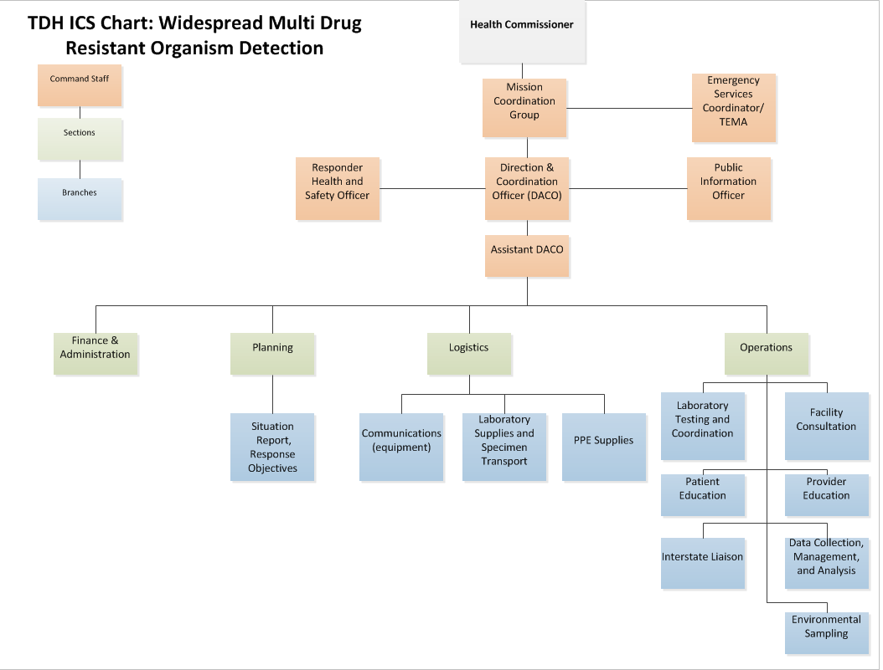

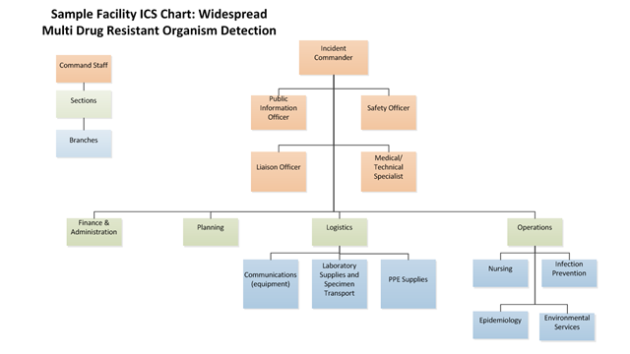

Module 5 Questions
Based on the information provided, participate in the discussion concerning the issues raised in Module 5. Identify any critical issues, decisions, requirements, or questions that should be addressed at this time.
The following questions are provided as suggested subjects that you may wish to address as the discussion progresses. These questions are not meant to constitute a definitive list of concerns to be addressed, nor is there a requirement to address every question. As a group, record your answers.
Incident Command
1. If your facility faced widespread MDRO activity, what roles do you think would be necessary? Similar to the example shown? Something different?
________________________________________________________________________________________________________________________________________________________________________________________________________________________________________________________________________________________________________________________________________________________________________________________________________________________________________________________________________________________________________________________________________________________________________________________________________________________________________________

2. In your facility, who could fill these roles? Would one person need to wear multiple hats?
________________________________________________________________________________________________________________________________________________________________________________________________________________________________________________________________________________________________________________________________________________________________________________________________________________________________________________________________________________________________________________________________________________________________________________________________________________________________________________
3. How could staff members who don’t have a specific role in a response support their colleagues?
________________________________________________________________________________________________________________________________________________________________________________________________________________________________________________________________________________________________________________________________________________________________________________________________________________________________________________________________________________________________________________________________________________________________________________________________________________________________________________

4. What support would you need from public health to achieve your objectives in a response like this?
________________________________________________________________________________________________________________________________________________________________________________________________________________________________________________________________________________________________________________________________________________________________________________________________________________________________________________________________________________________________________________________________________________________________________________________________________________________________________________
Communication Plan
You received back from screening and there is evidence of transmission. Your job is to outline how you would communicate critical information within your institution and to other impacted facilities.
Hospital A
- Is a highly connected facility
- LTACH A and Nursing Home A both frequently send patients to Hospital A
- 4 downstream facilities many patients from Hospital A: Nursing Home A, Nursing Home C, Rehabilitation Center A, and Rehabilitation Center B
- Hospital A
Nursing Home A

- Regularly receives patients from 3 facilities: Hospital A, Hospital B, and Hospital B
- Frequently sends patients to Rehabilitation Center A
- Consider active screening on all admissions
- Continue screening until two consecutive negative rounds

- What do you think public health would or should do with this information?
________________________________________________________________________________________________________________________________________________________________________________________________________________________________________________________________________________________________________________________________________________________________________________________________________________________________________________________________________________________________________________________________________________________________________________________________________________________________________________

2. How can your facility help inform upstream or downstream facilities of known cases?
________________________________________________________________________________________________________________________________________________________________________________________________________________________________________________________________________________________________________________________________________________________________________________________________________________________________________________________________________________________________________________________________________________________________________________________________________________________________________________

3. Are there any other issues that you think should be discussed at this time?
________________________________________________________________________________________________________________________________________________________________________________________________________________________________________________________________________________________________________________________________________________________________________________________________________________________________________________________________________________________________________________________________________________________________________________________________________________________________________________

Additional Questions:

Hospital A
2 out of 5 screening cultures from patients at the hospital are VIM positive. Roommate X (Mr. A’s initial hospital A roommate from January 31 who is now at Nursing Home A, first floor) also screened positive.

Nursing Home A
From the 30 residents screened from the nursing home, 28 residents agreed to be swabbed, and 12 have CRE. Carbapenem-resistance mechanism testing identifies two types of plasmid-mediated resistance mechanisms: 9 Klebsiella pneumoniae carbapenemase (KPC) and 3 VIM. Of note, Resident W (the patient who occupied Mr. A’s room after Mr. A was discharged back to the hospital) is one of the VIM- colonized residents. VIM-producing CRE have not been found in the region prior to this; however, KPC-producing CRE have been found before.
Internal Communications
- After the latest laboratory results, would your facility initiate incident command? Why or why not? ________________________________________________________________________________________________________________________________________________________________________________________________________________________________________________________________________________________________________________________________________________________________________________________________________________________________________________________________________________________________________________________________________________________________________________________________________________________________________________

2. Describe your communication process in Hospital A or Nursing Home A? Include your message, delivery, and communication flow. Indicate the appropriate individuals to receive messages. ________________________________________________________________________________________________________________________________________________________________________________________________________________________________________________________________________________________________________________________________________________________________________________________________________________________________________________________________________________________________________________________________________________________________________________________________________________________________________________

External Communications
Create a communication plan to external partners. It must be timely, deliver accurate information, and reach the appropriate people. It must address the following:

1. How would you like to disseminate information? Indicate the roles of the healthcare institution and public health?
________________________________________________________________________________________________________________________________________________________________________________________________________________________________________________________________________________________________________________________________________________________________________________________________________________________________________________________________________________________________________________________________________________________________________________________________________________________________________________

2. Address the timeline for your communication plan. How soon do you start?
________________________________________________________________________________________________________________________________________________________________________________________________________________________________________________________________________________________________________________________________________________________________________________________________________________________________________________________________________________________________________________________________________________________________________________________________________________________________________________
3. In what circumstances would your facility notify the public?
________________________________________________________________________________________________________________________________________________________________________________________________________________________________________________________________________________________________________________________________________________________________________________________________________________________________________________________________________________________________________________________________________________________________________________________________________________________________________________

Module 6: Next Steps
By partnering with the health department, you communicated the following…
The first round of screening is complete and the communication plan has been implemented.
Hospital A
- Continue contact precautions
- Inform downstream facilities
- Consider active screening on all admissions
- Continue screening until two consecutive negative rounds

Nursing Home A
- Continue contact precautions
- Screen individuals coming from hospital A
- Continue screening until two consecutive negative rounds

TDH Regions
- Alert downstream facilities (IPs) about novel CP-CRE
- Active screening for any patient transferred from Hospital A, NH A, and any patient in Hospital A or NH A at the time of transmission

What happens to the hospital, the nursing home, and Mr. A?
Your case is complete….
- You notify facilities that share patients with this facility of the cluster and suggest screening cultures of new admissions until the outbreak is controlled.

- The TDH HAI team visits the facility again to make sure practices are improving.

- The TDH HAI team elects to do additional point prevalence surveys of (2 weeks apart) to determine if there is further transmission. Both point prevalence surveys do not identify additional VIM- or KPC-producing CRE.

- Mr. A is discharged back to the nursing home with contact precautions.

Action Items:
- Ensure your facility fully understands the CRE reporting process to Public Health.

- Ensure your facility is educated on CRE and MDRO infection prevention and containment.

- Ensure that you have a laboratory point of contact for packaging swabs to ship to the regional lab.

- Speak to the public information officer (PIO) at your facility to develop messaging for facilities and the public for CRE of concern.

 | APPENDIX A: EXERCISE AGENDA
 | TIME | ACTIVITY
 | 9:30 am - 10:00 am |  | Check-in and Registration
 | 10:00 am – 10:20 am |  | Brief Overview of Concepts  - What is CRE/CP-CRE? Why do we care?  - ARLN Containment Strategies  - Three tiered Response  - TN Hospital Network
 | 10:20 am – 12:00 pm |  | Tabletop Exercise  - Introduction to the Case  - Notification  - Case History  - Facility Assessment  - Screening Plan
 | 12:00 pm – 1:00 pm |  | Lunch  - PPE Demonstration
 | 1:00 pm – 2:30 pm |  | Continue Tabletop Exercise  - Incident Command  - Communication Plan  - Next Steps

