Department of Health & Human Services
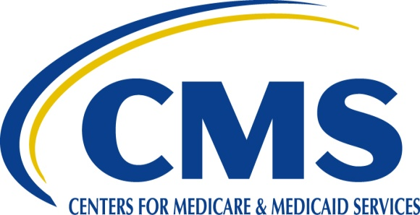
Centers for Medicare & Medicaid Services
61 Forsyth Street, Suite 4T20
Atlanta, Georgia 30303-8909

October 1, 2019

Ms. Heather Lansaw
VP of Senior Care Services
Tennessee Health Management, Inc. d/b/a
American Health Communities (AHC)
201 Jordan Road, Suite 200
Franklin, Tennessee 37067
hlansaw@ahcseniorcare.com
mbailey@amhealthpartners.com

Re: Request for State Use of CMP Funds
CMP Request No. 2019-04-TN-0919
CMP Fund Request Approved: $457,839.26

Dear Ms. Heather Lansaw and Mr. Mike Bailey:

Sections 1819(h)(2)(B)(ii)(IV)(ff) and 1919(h)(3)(C)(ii)(IV)(ff) of the Social Security Act incorporate specific provisions of the Patient Protection and Affordable Care Act pertaining to the collection and uses of civil money penalties (CMPs) imposed by the Centers for Medicare & Medicaid Services (CMS) when nursing homes do not meet requirements for long term care facilities. In accordance with 42 CFR § 488.433 and CMS Survey & Certification Memo 12-13-NH (effective January 1, 2012) States must obtain approval from CMS for the use of federally imposed CMP funds.

Our office has reviewed the proposal submitted by Tennessee Health Management d/b/a American Health Communities, Inc. (AHC) for $457,839.26 to implement the “Activities, Restorative, and Therapy in Sync (ARTS) program. This is a three-year civil money penalty (CMP) project. AHC seeks to purchase “It’s Never Too Late”, adaptive computer technology for eight nursing homes in the Nashville Region. The eight facilities provide services to approximately 602 nursing home residents. The goals of the ARTS: iN2L project are to improve or maintain activities of daily living (ADL) function, and to increase participation in person-centered recreational and rehabilitation activities. Implementation of iN2L technology is a proven approach for improving residents’ quality of life. The technology enhances person-centered care by providing staff with the tools necessary to engage residents in individualize therapy, individual or group recreation activities, and restorative care. iN2L also offers dementia residents effective programming to help manage their behavior through non-pharmacological means.

The nursing homes included in the three-year project are:

- Bethesda Health Care Center, Inc., CCN #44-5427
- Clarksville Nursing and Rehabilitation Center, Inc., CCN #44-5455
- Cumberland Health Care and Rehabilitation Center, Inc. CCN #44-5262
- Meadowbrook Health and Rehabilitation Center, Inc., CCN #44-5443
- Mt. Juliet Nursing and Rehabilitation, Inc., CCN# 44-5439
- Northside Health Care Nursing and Rehabilitation Center, Inc., CCN #44-5373
- Vanco Health Care and Rehabilitation, Inc., CCN #44-5446
- Waverly Health Care and Rehabilitation Center, Inc., CCN #44-5251
Congratulations, the CMP request has been approved. This letter constitutes your notice of approval to receive Federal civil money penalty (CMP) funds in the amount of $457,839.26. Reporting on the ARTS iN2L project is an important and integral aspect of receiving civil money penalty (CMP) funds from CMS. Reports shall disclose how each individual facility is meeting project deliverables. Quarterly reports shall also address any new findings, pitfalls, successes, and updates on the project, including adherence to the budget, and the establishment of a train-the-trainer program. The final quarterly report shall include information on lessons learned and best practices for incorporating adaptive computer technology into resident activities, restorative nursing care and therapy services.

Submit quarterly reports to the address listed below. Reports shall include a cover letter, the name of the project leader, along with their telephone number and e-mail address; and the CMP request number 2019-04-TN-0919 on all pages of the report.

Submit reports to:

Stephanie M. Davis, MS., RD
LTC Certification & Enforcement Branch
Centers for Medicare & Medicaid Services
Sam Nunn Atlanta Federal Center
61 Forsyth Street, S.W., Suite 4T20
Atlanta, Georgia 30303

The goals and results of this CMP project shall be shared with CMS State Agency Director’s at a meeting date and time to be provided by CMS. A copy of the contract with the state survey agency shall also be provided to CMS.

State use of civil money penalty fund requests are not subject to an appeal. This CMP request was made possible by the Centers for Medicare and Medicaid Services (CMS) in partnership with the Tennessee State Survey Agency.

If you have any questions regarding this matter, please contact Stephanie M. Davis at (404) 562-7471.

Sincerely,

/s/

Linda D. Smith
Associate Regional Administrator
Division of Survey & Certification

cc: Stephanie M. Davis
Sally Pitt
Jacy Weems
Shaquallah Shanks
Louise Ryan
CMPRP Team

