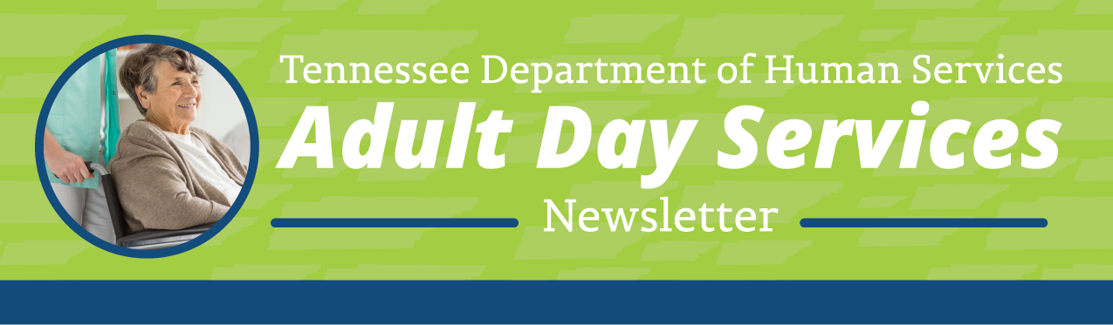
Greetings from your partners at the Tennessee Department of Human Services (TDHS), Adult Day Services Team!
Welcome to the Adult Day Services (ADS) Quarterly Newsletter. This newsletter shares information on topics related to your day-to-day operations as a licensed Adult Day Services (ADS) provider.
In this edition of the newsletter, we would like to spotlight one of the new Adult Day Services providers, introduce you to the new Program Manager for Adult Day Services, and provide information on upcoming events.

It’s Conference Time!
The annual TAADS Conference will be May 8th-10th. Register and join today at www.TAADS.net or email info@taads.net.
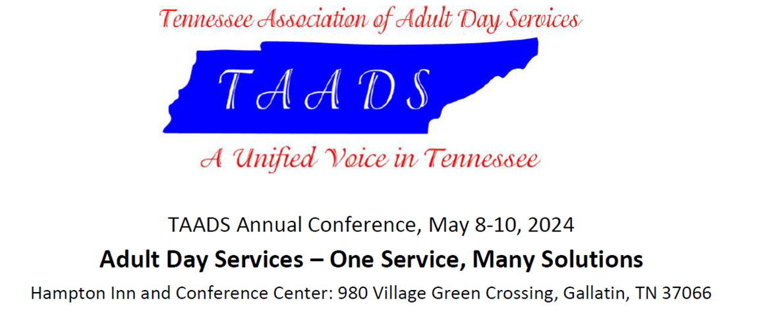
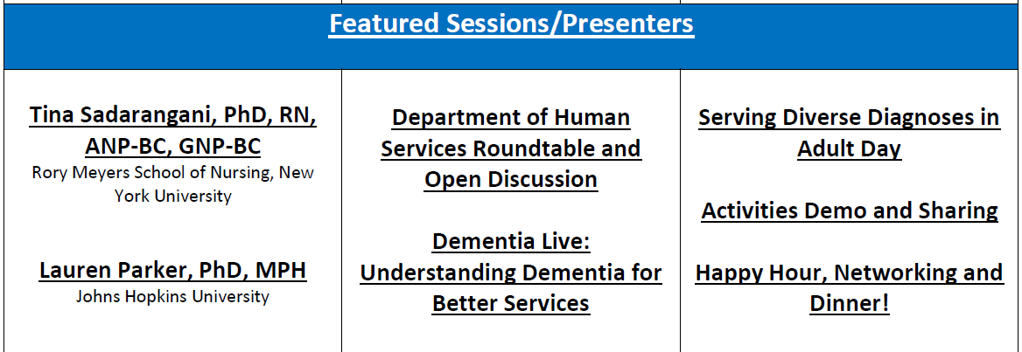

Program Spotlight: Grace Adult Day Center

The information below has been provided by Lisa Hicks, Owner/Director:
Grace Adult Day Center opened in Dec of 2023 as Blount County’s only Licensed Adult Center. Grace is owned and operated by a Nurse that has served the Community for over 25 years. We are licensed as a Socialization Program and seek to alleviate the burden of caregivers and engage our clients in a structured program to strengthen what remains while they age in peace.
We welcome adults (18+ years) from all stages of life to spend the day with us at a fraction of the cost of private home care. Grace Adult Center helps enrich life and create memories that matter. Each day we serve a hot breakfast, a home-cooked lunch, and an evening snack that is sure to please everyone’s dietary needs and tastes! Additionally, we provide a secure environment for therapeutic activities, as well as activities aimed at helping participants achieve optimal physical and mental functioning. Our staff is specially trained to help your loved ones enjoy life, laugh together, and age in peace.
Our hours are Monday through Friday 8 AM to 5 PM. We are contracted through The Veterans Administration as well as TennCare Medicaid choices. How can we help you and your loved ones to continue to live, grow and enjoy life?

What’s New????
Meet Amy Joy, the new DHS Program Manager for Adult Day Services. Amy has worked for the Department of Human Services for 15 years with Child Care Assessment and Child & Adult Care Licensing. She looks forward to meeting and partnering with Adult Day Services providers across the state.

Coming Soon
A new BacTrak/Provider Portal interface is coming at the end of April. All background check results will come straight to your portal and you can link them to your staff records. Copies of clearance letters will also be stored there so that you have easy access anytime you need them. All providers will receive an email closer to the end of April with more details about the interface and a resource guide to assist you in using the new features.

Licensing Violations or Illegal Operations
To report suspected adult day services licensing violations or possible illegal operations call the Child and Adult Care Complaint Hotline at 1-800-462-8261 or email AdultDayServices.DHS@tn.gov.

Reminders
We will feature existing and newly opened ADS agencies in the Program Spotlight section of each issue. If you wish to be featured, have ideas about potential topics or general feedback please reach out to us by email at, AdultDayServices.DHS@tn.gov.

Quarterly ADS Newsletters are posted at the ADS webpage of the TDHS website for your reference at, https://www.tn.gov/humanservices/adults/adult-day-services.html.

