Acute Hepatitis C (Tennessee and U.S.)

Figure 1. Reported Cases of Acute Hepatitis C (Tennessee, 2005-2014)

Source: CEDEP hepatitis surveillance, TDH

Table 1. Reported Cases of Acute Hepatitis C (U.S. and Tennessee, 2010-2014)
 |  | 2010 | 2011 | 2012 | 2013 | 2014≠
US | case rate* | 0.3 | 0.4 | 0.6 | n/a | n/a
 | cases | 850 | 1,229 | 1,778 | n/a | n/a
TN | case rate* | 0.7 | 1.3 | 2.0 | 1.5 | 1.9
 | cases | 46 | 83 | 129 | 98 | 122
 | rank | 4th | 4th | 4th | 6th | n/a
Sources: http://www.cdc.gov/hepatitis/Statistics/2013Surveillance/index.htm and ≠CEDEP hepatitis surveillance, TDH
* per 100,000 population

Figure 2. Distribution of Reported Cases of Acute Hepatitis C by County (Tennessee, 2010-2014)
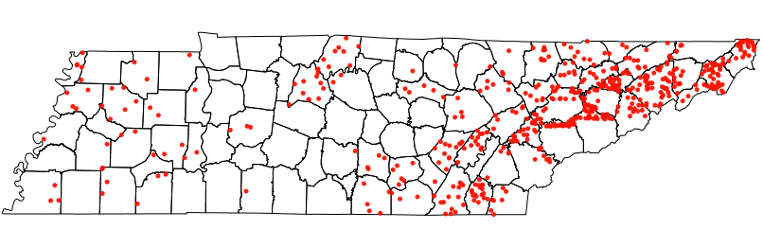
Source: CEDEP hepatitis surveillance, TDH

