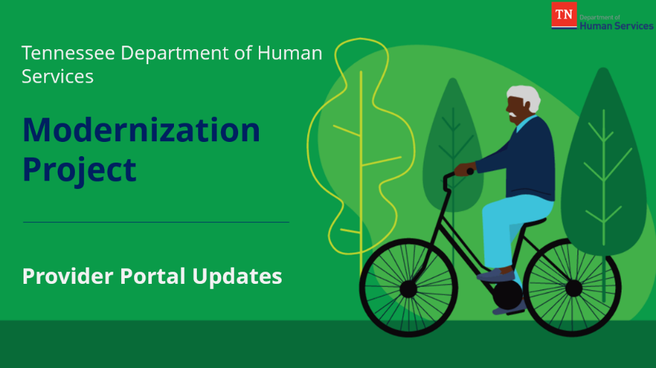

ADS Provider Portal Town Hall Summary

Presented on February 22nd, 2023

If you would like to revisit any topics covered during the session or need to review the material for the first time, please access the Town Hall materials on our Modernization Resources Page under “Provider Town Hall Replays.” You may also listen to each topic as they were presented by using the timestamp links included below.
What to Know About Updates in the Provider Portal
Topic | Key Takeaways | Watch here!
Annual Report | - Updates to the Annual Report in the Provider Portal have been made to reduce your time spent completing the report each year.  - Annual Reports will now auto-populate with the latest information available for your facility.  - New tabs are available on the Annual Report to update and reuse contact information for various roles at your facility.  - New features have been added to the Supporting Documentation screen to reuse documents from previous years.  - Dropdown options have been updated throughout the Annual Report to be more inclusive of specific ADS reporting needs. | Annual Report Demo
Change Report | - New instructions within the Change Report inform you that you are not required to complete a Change Report in full.  - Screen updates have been made throughout the Change Report to provide flexibility when entering information specific to your agency.  - New tabs are available in the Change Report to update contact information for various roles at your facility.  - Dropdown options have been updated throughout the Change Report to be more inclusive of specific ADS reporting needs. | Change Report Demo
Incident/Injury Report | - Updates to the Incident/Injury Report in the Provider Portal have been made to capture more accurate information using simplified fields and updated dropdown options.  - A new table allows you to add information for each participant directly involved in an Incident/Injury. | Incident / Injury Demo
We Are Here for You!
If you have any questions on the Provider Portal updates or the Modernization Project, please contact the TN Child and Adult Care Help Desk Team using the information listed below.
Hours of Operation | Monday - Saturday  7:00am – 9:00pm CST
Toll-Free Number | 833-TDHS-CCP (833-834-7227)
Website | http://tnchildcarehelpdesk.org
Email | Tdhs_ccp@utk.edu

